INNOVA JUNIOR COLLEGE
JC 2 PRELIMINARY EXAMINATION 2
in preparation for General Certificate of Education Advanced Level
Higher 1

CANDIDATE
NAME

CLASS INDEX NUMBER

GENERAL PAPER  Paper 1  Additional Materials: Writing paper | 8806/01  29 August 2012  1 hour 30 minutes

READ THESE INSTRUCTIONS FIRST

Write your name and class on all the work you hand in.
Write in dark blue or black pen on both sides of the paper.
Do not use staples, paper clips, highlighters, glue or correction fluid.

Answer one question.
Note that 20 marks out of 50 will be awarded for your use of language.

At the end of the examination, fasten all your work securely together. All questions in this paper carry equal marks.

For Examiner’s Use
Question No
Content | /30
Language | /20
Total | /50

This document consists of 2 printed pages.
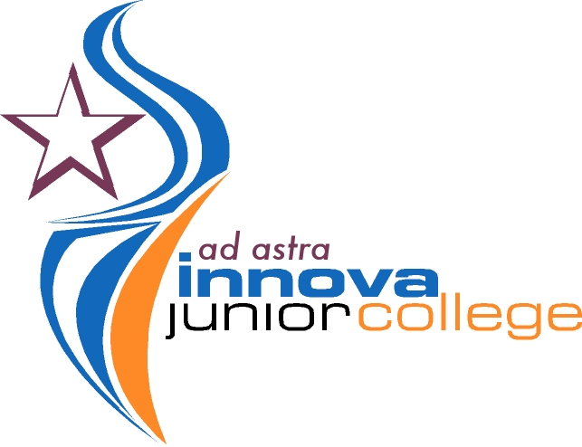 | Innova Junior College | [Turn over]

Answer one question from this Paper.

Answers should be between 500 and 800 words in length.

- ‘Museums serve no purpose in modern society.’ Discuss.

- Is living longer really a good thing in today’s world?

- Should schools place greater emphasis on character development today? Discuss this in relation to your society.

- ‘Businesses are driven mainly by greed.’ Is this a fair comment?

- ‘Tourism will be the death of the environment.’ Discuss.

- ‘Do what you enjoy.’ How far should one follow this advice?

- ‘Technology divides rather than unites.’ How true is this in your society?

- ‘Studying history is a waste of time.’ Discuss.

- To what extent should users of social media have the right to decide what goes public?

- ‘As science advances, morality declines.’ Do you agree?

- How far should the State be involved in family life?

- Consider the view that fear is our greatest weakness.

End of Paper

